Practical no: 4

Aim: a. Logistic Regression Perform binary classification using logistic regression. Calculate accuracy, precision, recall, and understand the ROC curve.
Description:
Logistic Regression is a statistical model used for predicting the probability of a binary outcome (e.g., 0 or 1, yes or no). Unlike linear regression, it applies the sigmoid (logistic) function to map predicted values to probabilities in the range [0, 1]. A threshold (commonly 0.5) is used to classify observations into one of two classes.
Steps:
- Data Preparation
  - Load the dataset containing features (independent variables) and binary labels (dependent variable).
  - Split the data into training and testing sets.
- Model Training
  - Fit a logistic regression model to the training data using maximum likelihood estimation.
  - The model learns weights for each feature to best separate the two classes.
- Prediction & Evaluation
  - Predict the class labels for the test set.
  - Calculate performance metrics:
    - Accuracy – proportion of correctly classified instances.
    - Precision – proportion of predicted positives that are actual positives.
    - Recall (Sensitivity) – proportion of actual positives that are correctly identified.
- ROC Curve & AUC
  - Plot the Receiver Operating Characteristic (ROC) curve by varying the classification threshold and plotting True Positive Rate vs. False Positive Rate.
  - Compute the Area Under Curve (AUC) to quantify model performance (AUC = 1 indicates perfect classification, 0.5 indicates random guessing).
Code:
import numpy as np
import matplotlib.pyplot as plt
from sklearn.datasets import load_breast_cancer
from sklearn.linear_model import LogisticRegression
from sklearn.model_selection import train_test_split
from sklearn.metrics import (
accuracy_score,
precision_score,
recall_score,
roc_curve,
roc_auc_score,
classification_report,
)
# 1. Load dataset
data = load_breast_cancer()
X = data.data
y = data.target

# 2. Split dataset into train/test
X_train, X_test, y_train, y_test = train_test_split(X, y, test_size=0.2, random_state=42)

# 3. Train logistic regression model
model = LogisticRegression(max_iter=10000)
model.fit(X_train, y_train)

# 4. Make predictions
y_pred = model.predict(X_test)
y_prob = model.predict_proba(X_test)[:, 1] # Probabilities for ROC curve

# 5. Evaluate the model
accuracy = accuracy_score(y_test, y_pred)
precision = precision_score(y_test, y_pred)
recall = recall_score(y_test, y_pred)
roc_auc = roc_auc_score(y_test, y_prob)

print("=== Classification Report ===")
print(classification_report(y_test, y_pred))
print(f"Accuracy : {accuracy:.2f}")
print(f"Precision: {precision:.2f}")
print(f"Recall : {recall:.2f}")
print(f"ROC AUC : {roc_auc:.2f}")

# 6. Plot ROC Curve
fpr, tpr, thresholds = roc_curve(y_test, y_prob)
plt.figure(figsize=(8,6))
plt.plot(fpr, tpr, label=f"Logistic Regression (AUC = {roc_auc:.2f})")
plt.plot([0, 1], [0, 1], 'k--', label='Random Guess')
plt.xlabel('False Positive Rate')
plt.ylabel('True Positive Rate')
plt.title('ROC Curve')
plt.legend()
plt.grid()
plt.show()

Output:
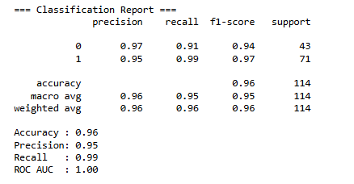
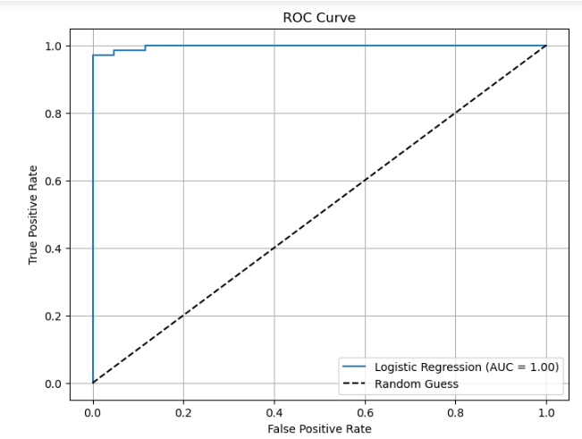
Learnings:
- Understood logistic regression for binary classification using the sigmoid function.
- Learned to calculate accuracy, precision, and recall for performance evaluation.
- Understood the use of ROC curve and AUC to assess classification quality.
- Recognized that threshold choice affects predictions and model performance.

Aim: b. k-nearest Neighbor Implement and demonstrate k-nearest Neighbor algorithm. Read the training data from .CSV file and build a model to classify the test sample. Print both correct and wrong predictions.
Description:
k-Nearest Neighbor is a non-parametric, instance-based learning algorithm used for classification and regression. In classification, the algorithm predicts the class of a test sample based on the majority class among its k closest training samples, determined using a distance metric (commonly Euclidean distance).
Steps:
- Data Loading – Read the training data from a .CSV file containing features and class labels.
- Model Building – Choose the value of k and a suitable distance metric.
- Prediction – For each test sample:
  - Find the k nearest neighbors in the training data.
  - Assign the majority label from these neighbors as the prediction.
- Evaluation – Compare predicted labels with actual labels to print correct and wrong predictions.
Applications:
Pattern recognition, recommendation systems, handwriting recognition, medical diagnosis, etc.
Code:
import pandas as pd
from sklearn.model_selection import train_test_split
from sklearn.neighbors import KNeighborsClassifier
import matplotlib.pyplot as plt

# Step 1: Read dataset (change to .csv if needed)
df = pd.read_excel("data.xlsx") # or pd.read_csv("data.csv")

# Step 2: Split features & target
X = df.iloc[:, :-1]
y = df.iloc[:, -1]

# Step 3: Train-Test Split
X_train, X_test, y_train, y_test = train_test_split(
X, y, test_size=0.3, random_state=42
)
# Step 4: Train KNN Model
k = 3
knn = KNeighborsClassifier(n_neighbors=k)
knn.fit(X_train, y_train)

# Step 5: Predictions
y_pred = knn.predict(X_test)

# Step 6: Separate correct & wrong predictions for plotting
correct_idx = [i for i in range(len(y_test)) if y_pred[i] == y_test.iloc[i]]
wrong_idx = [i for i in range(len(y_test)) if y_pred[i] != y_test.iloc[i]]

# Step 7: Plot results
plt.figure(figsize=(7, 5))

# Correct predictions (Green)
plt.scatter(
X_test.iloc[correct_idx, 0], X_test.iloc[correct_idx, 1],
c='green', label='Correct Prediction', s=100, edgecolors='black'
)
# Wrong predictions (Red)
plt.scatter(
X_test.iloc[wrong_idx, 0], X_test.iloc[wrong_idx, 1],
c='red', label='Wrong Prediction', s=100, edgecolors='black'
)
plt.xlabel("Feature 1")
plt.ylabel("Feature 2")
plt.title(f"KNN Classification (k={k})")
plt.legend()
plt.grid(True)
plt.show()
Output:
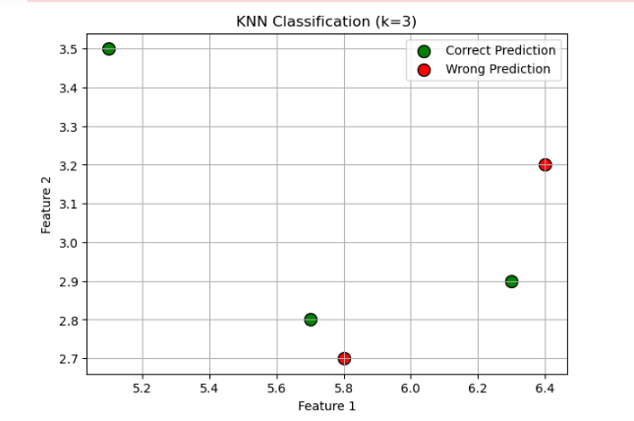
Learnings:
Learned that k-NN classifies based on proximity to labeled data points.
Understood the importance of choosing an appropriate k value and distance metric.
Observed how k-NN makes instance-based predictions without explicit training.
Identified that model performance depends on data scaling and noise sensitivity.
Aim: c. Decision Tree Build decision tree classifier or regressor. Control hyperparameters like tree depth to avoid overfitting. Visualize the tree.
Description:
A Decision Tree is a supervised learning algorithm that splits data into subsets based on feature values, forming a tree-like structure.
Each internal node represents a decision based on a feature, branches represent the outcome, and leaves represent the class label (classification) or predicted value (regression).
Hyperparameters such as max_depth help control overfitting by limiting tree growth.
Visualization of the tree helps in understanding the model’s decision-making process.
Key points:
- Type: Supervised, interpretable model.
- Splitting criteria: Gini Index, Entropy (classification) or MSE (regression).
- Control overfitting: Limit depth, minimum samples per split.
- Advantage: Easy to interpret, works with numerical and categorical data.
- Limitation: Prone to overfitting without constraints.
Code:
# Import required libraries
from sklearn.datasets import load_iris
from sklearn.model_selection import train_test_split
from sklearn.tree import DecisionTreeClassifier, plot_tree
import matplotlib.pyplot as plt

# Load dataset (Iris dataset for classification)
iris = load_iris()
X = iris.data
y = iris.target

# Split data into train & test sets
X_train, X_test, y_train, y_test = train_test_split(X, y, test_size=0.2, random_state=42)

# Build Decision Tree Classifier with controlled depth
clf = DecisionTreeClassifier(max_depth=3, random_state=42)
clf.fit(X_train, y_train)

# Accuracy
print("Training Accuracy:", clf.score(X_train, y_train))
print("Test Accuracy:", clf.score(X_test, y_test))

# Visualize the decision tree
plt.figure(figsize=(12,8))
plot_tree(clf, feature_names=iris.feature_names, class_names=iris.target_names, filled=True)
plt.show()
Output:
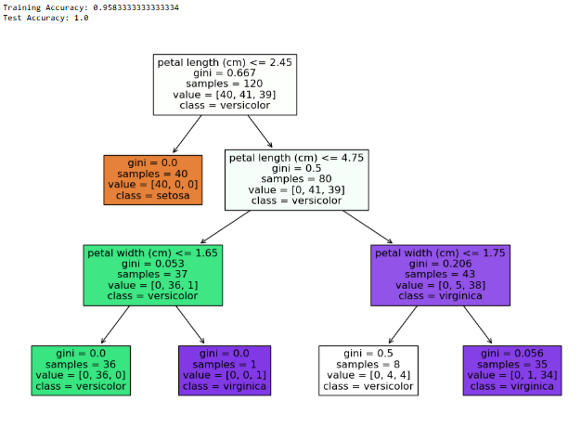

Learnings:
Learned how to build a Decision Tree classifier to classify data based on feature splits.
Understood the importance of controlling hyperparameters like max_depth to prevent overfitting and improve generalization.
Learned how splitting criteria such as Gini index or Entropy guide node creation.
Practiced visualizing the tree to interpret model decisions and understand feature importance.

Aim: d. Support Vector Machine Implement a Support Vector Machine for any relevant dataset.
Description:
Support Vector Machine is a supervised algorithm that finds the optimal hyperplane that best separates data into classes by maximizing the margin between the nearest points of different classes (support vectors).
SVM can handle non-linear boundaries using kernel functions such as RBF, polynomial, or sigmoid.
It is effective in high-dimensional spaces but requires feature scaling for optimal results.
Key points:
- Type: Supervised, margin-based classifier.
- Kernel trick: Transforms data into higher dimensions for separation.
- Advantage: High accuracy for well-separated classes, works in high dimensions.
- Limitation: Computationally expensive for large datasets, sensitive to kernel parameters.
Code:
# Import libraries
import matplotlib.pyplot as plt
from sklearn import datasets
from sklearn.model_selection import train_test_split
from sklearn.svm import SVC
from sklearn.preprocessing import StandardScaler
from sklearn.metrics import classification_report, accuracy_score
import numpy as np

# Load Iris dataset
iris = datasets.load_iris()
X = iris.data[:, :2] # Taking only first 2 features for visualization
y = iris.target

# Split data
X_train, X_test, y_train, y_test = train_test_split(X, y, test_size=0.3, random_state=42)

# Standardize features (important for SVM)
scaler = StandardScaler()
X_train = scaler.fit_transform(X_train)
X_test = scaler.transform(X_test)

# Create SVM model (RBF kernel)
svm_clf = SVC(kernel='rbf', C=1.0, gamma='scale')
svm_clf.fit(X_train, y_train)

# Predictions & Accuracy
y_pred = svm_clf.predict(X_test)
print("Accuracy:", accuracy_score(y_test, y_pred))
print("\nClassification Report:\n", classification_report(y_test, y_pred))

# Visualize decision boundaries
x_min, x_max = X_train[:, 0].min() - 1, X_train[:, 0].max() + 1
y_min, y_max = X_train[:, 1].min() - 1, X_train[:, 1].max() + 1
xx, yy = np.meshgrid(np.arange(x_min, x_max, 0.02),
np.arange(y_min, y_max, 0.02))
Z = svm_clf.predict(np.c_[xx.ravel(), yy.ravel()])
Z = Z.reshape(xx.shape)

plt.figure(figsize=(8,6))
plt.contourf(xx, yy, Z, alpha=0.3)
plt.scatter(X_train[:, 0], X_train[:, 1], c=y_train, edgecolors='k', marker='o', label="Train")
plt.scatter(X_test[:, 0], X_test[:, 1], c=y_test, edgecolors='k', marker='s', label="Test")
plt.xlabel('Feature 1 (Sepal length)')
plt.ylabel('Feature 2 (Sepal width)')
plt.title('SVM Decision Boundary (RBF Kernel)')
plt.legend()
plt.show()
Output:
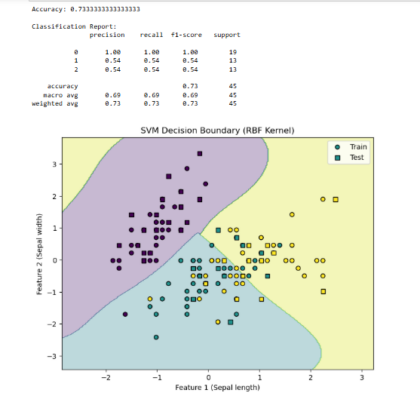
Learnings:
- Learned how SVM finds the optimal hyperplane to separate different classes with the maximum margin.
- Understood the use of kernel functions (e.g., linear, RBF) to handle non-linear classification problems.
- Learned the importance of feature scaling for SVM performance.
Aim: e. Random Forest ensemble Train the random forest ensemble. Experiment with the number of trees and feature sampling. Compare performance to a single decision tree.
Description:
Random Forest is an ensemble learning method that builds multiple decision trees and combines their predictions for better accuracy and generalization.
It uses bootstrap sampling (bagging) to train trees on random subsets of data and feature sampling to select random subsets of features at each split.
The final output is obtained via majority voting (classification) or averaging (regression).
Increasing the number of trees generally improves stability.
Key points:
- Type: Ensemble, bagging method.
- Reduces overfitting compared to single decision trees.
- Hyperparameters: n_estimators (trees), max_features (feature sampling).
- Advantage: Robust, high accuracy, works on large datasets.
- Limitation: Less interpretable than a single decision tree.
Code:
# Import libraries
from sklearn.datasets import load_iris
from sklearn.model_selection import train_test_split
from sklearn.tree import DecisionTreeClassifier
from sklearn.ensemble import RandomForestClassifier
from sklearn.metrics import accuracy_score

# Load dataset
iris = load_iris()
X, y = iris.data, iris.target

# Split into train & test
X_train, X_test, y_train, y_test = train_test_split(
X, y, test_size=0.3, random_state=42
)

# Single Decision Tree
dt_clf = DecisionTreeClassifier(max_depth=3, random_state=42)
dt_clf.fit(X_train, y_train)
dt_pred = dt_clf.predict(X_test)
dt_acc = accuracy_score(y_test, dt_pred)

# Random Forest (Experiment: n_estimators and max_features)
rf_clf = RandomForestClassifier(
n_estimators=100, # number of trees
max_features='sqrt', # number of features to consider at each split
random_state=42
)
rf_clf.fit(X_train, y_train)
rf_pred = rf_clf.predict(X_test)
rf_acc = accuracy_score(y_test, rf_pred)

# Print results
print("Decision Tree Accuracy:", dt_acc)
print("Random Forest Accuracy:", rf_acc)

# Experiment with different number of trees
for trees in [10, 50, 100, 200]:
rf_exp = RandomForestClassifier(n_estimators=trees, random_state=42)
rf_exp.fit(X_train, y_train)
acc = accuracy_score(y_test, rf_exp.predict(X_test))
print(f"Random Forest ({trees} trees) Accuracy: {acc:.4f}")
Output:
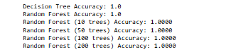
Learnings:
Learned that Random Forest is an ensemble of Decision Trees, combining multiple trees to improve accuracy and reduce overfitting.
Understood the effect of number of trees (n_estimators) and feature sampling on model performance.
Observed that Random Forest generally performs better than a single Decision Tree due to bagging and random feature selection.
Learned how to compare metrics like accuracy or F1-score to evaluate performance improvements over a single tree.

Aim: f. Gradient Boosting machine Implement a gradient boosting machine. Tune hyper parameters and explore feature importance.
Description:
Gradient Boosting is an ensemble method that builds models sequentially, where each new tree corrects the errors of the previous ones.
It uses gradient descent to minimize a loss function by fitting new trees to the residual errors of previous predictions.
Hyperparameters like learning rate, n_estimators, and max_depth control performance and overfitting.
Feature importance analysis can be performed to identify the most influential variables.
Key points:
- Type: Ensemble, boosting method.
- Learning process: Sequentially adds weak learners (trees).
- Hyperparameters: Learning rate, number of trees, depth of trees.
- Advantage: High predictive accuracy, handles mixed data types.
- Limitation: Can overfit if not tuned, longer training time.
Code:
# Import libraries
from sklearn.datasets import load_iris
from sklearn.model_selection import train_test_split
from sklearn.ensemble import GradientBoostingClassifier
from sklearn.metrics import accuracy_score
import matplotlib.pyplot as plt
import numpy as np

# Load dataset
iris = load_iris()
X, y = iris.data, iris.target

# Split data
X_train, X_test, y_train, y_test = train_test_split(
X, y, test_size=0.3, random_state=42
)

# Build Gradient Boosting Model with tuned parameters
gb_clf = GradientBoostingClassifier(
n_estimators=150, # number of boosting stages
learning_rate=0.1, # step size shrinkage
max_depth=3, # depth of individual trees
random_state=42
)
gb_clf.fit(X_train, y_train)

# Predictions
y_pred = gb_clf.predict(X_test)
accuracy = accuracy_score(y_test, y_pred)

print("Gradient Boosting Accuracy:", accuracy)

# --- Feature Importance ---
importances = gb_clf.feature_importances_
indices = np.argsort(importances)[::-1]

plt.figure(figsize=(8, 5))
plt.title("Feature Importances (Gradient Boosting)")
plt.bar(range(X.shape[1]), importances[indices], color="skyblue", align="center")
plt.xticks(range(X.shape[1]), np.array(iris.feature_names)[indices], rotation=45)
plt.tight_layout()
plt.show()

# --- Quick Hyperparameter Experiment ---
for lr in [0.01, 0.05, 0.1, 0.2]:
gb_exp = GradientBoostingClassifier(n_estimators=150, learning_rate=lr, max_depth=3, random_state=42)
gb_exp.fit(X_train, y_train)
acc = accuracy_score(y_test, gb_exp.predict(X_test))
print(f"Learning Rate {lr}: Accuracy = {acc:.4f}")
Output:
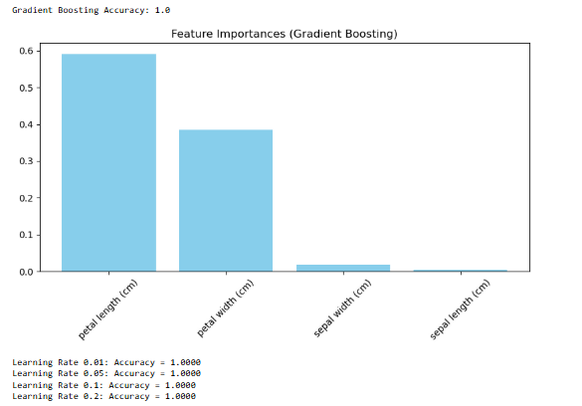
Learnings:
Learned that GBM builds models sequentially, where each new tree corrects the errors of the previous one.
Understood the role of key hyperparameters like learning rate, number of estimators, and max depth in controlling performance and overfitting.
Explored feature importance to identify which variables most influence the model’s predictions.
Observed that GBM often achieves higher accuracy than single models but may require careful tuning to prevent overfitting.

